Social Studies Grade 6 Training Test
Question Number | Answer | DE Content Benchmark
1 | A | G.2.6-8a
2 | D | G.2.6-8a
3 | 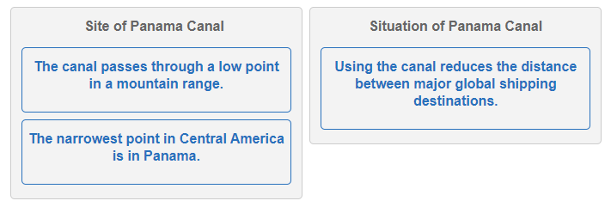 | G.3.6-8b
4 | 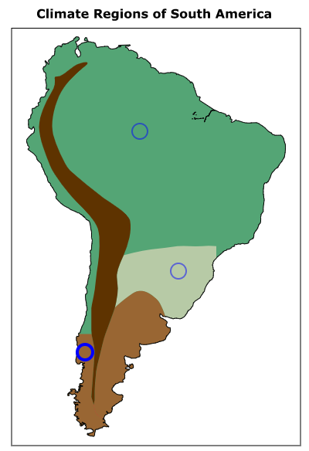 | G.4.6-8a
5 | 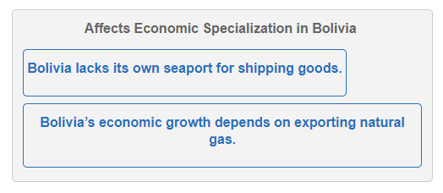 | G.4.6-8a
6 | A | G.2.6-8a
7 | 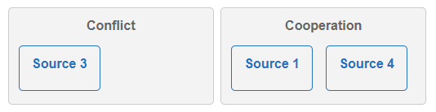 | G.4.6-8b
8 | B | G.3.6-8a
9 | 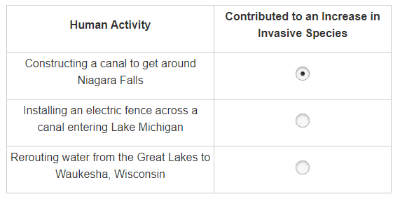 | G.2.6-8a
10 | D | G.4.6-8a
11 | 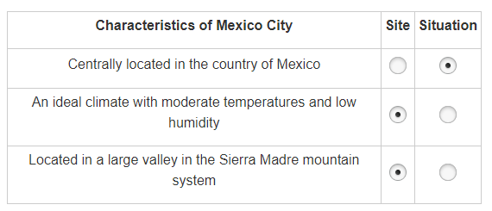 | G.3.6-8b
12 | A | G.2.6-8a
13 | 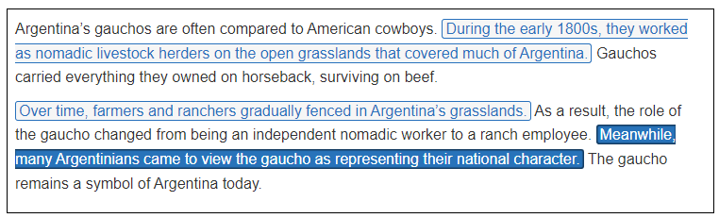 | G.3.6-8a
14 | 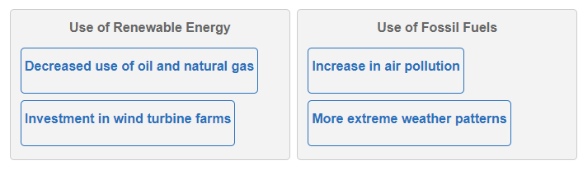 | G.2.6-8a
15 | B | G.2.6-8a

